Installing New Browser for Testing 2017

OS 10.7, 10,8, 10.9 and 10.10 are noted on the CAASPP website as being the only supported Operating Systems for Macs (desktops & laptops) this year.

For Macs (Laptops and/or Desktops) that were used for testing last year, they may have a separate TESTING account unless your site installed the testing browser in the Student account. In order to ready them for this years testing, the NEW CASecureBrowser (version 9), needs to be INSTALLED. (No need to uninstall the old version this year, as the new version will replace it.)

NOTE: If your site will be using Macs (Laptops and/or Desktops), that were not used last year, then you only need to INSTALL the CASecureBrowser in the STUDENT account, unless you wish to set up a separate TESTING account for it.

For Macs that have a TESTING account, here’s the steps:

Select and open the ESD Teacher account on the student computer
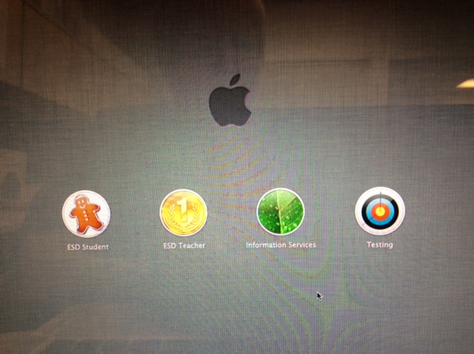

First, determine what OS (Operating System) your Mac has by going under the Apple in the menu at the top of the screen, and use the pull-down to go to “About This Mac”. A screen will pop up that notes the OS of the Mac. (Example below: Version 10.7.5, thus OS 10.7)
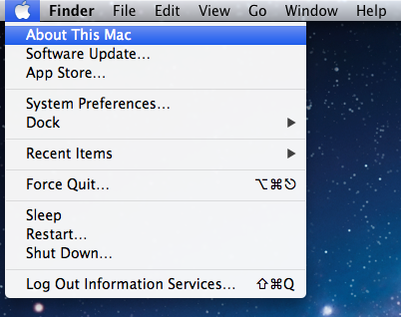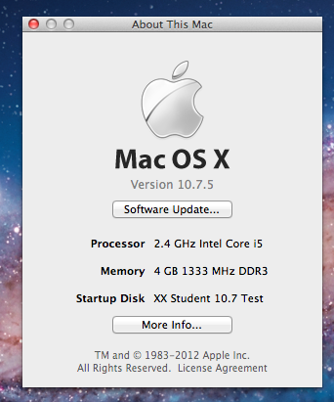

Open Firefox and go to: http://ca.browsers.airast.org

Scroll down to “Download Secure Browsers” section and find the one for Mac OS 10.7 – 10.12

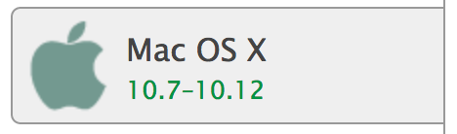

Once you click on that section of the page, on the right side will be the Download for the Mac OS X (10.7 – 10.12) Secure Browser. Click on the “Download Browser” to download it.
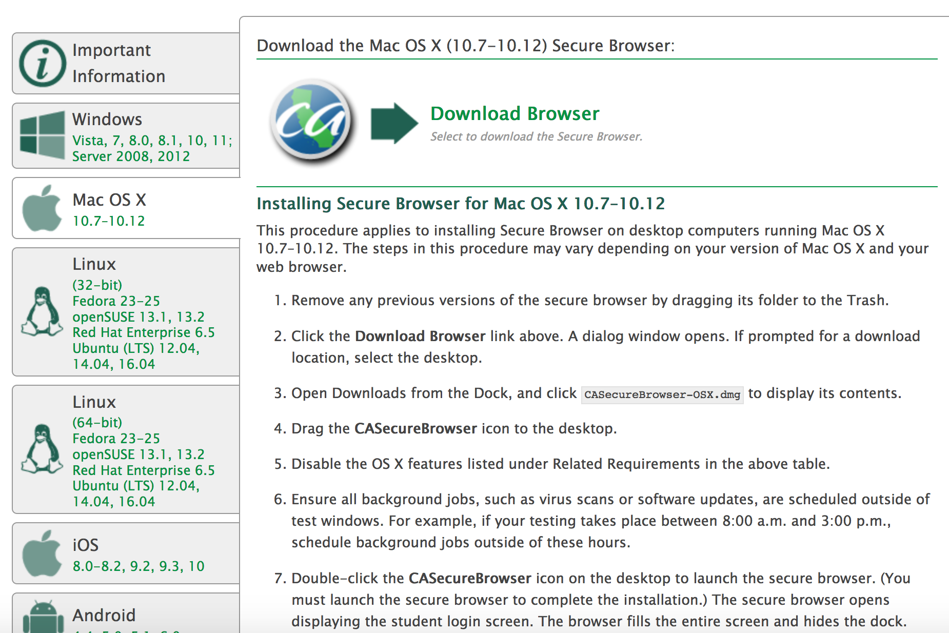

A window will pop up asking if you would like to save this file,
Click on “Save File”
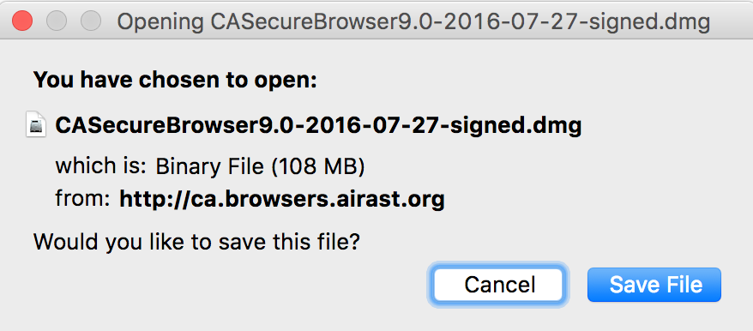

Open the Downloads folder to find:
CASecureBrowser9.0-2016-07-27-signed.dmg
and double click on it.

In the window that pops up, drag the “CASecureBrowser” icon into the alias for the Application folder.
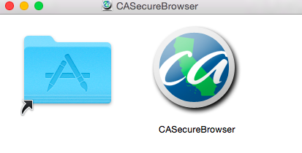

If a window pops up on the screen asking if you want to replace the older item, click on Replace:
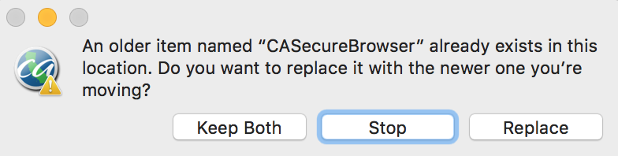

Your CASecureBrowser (version 9) is now in your Applications list.

Double click on CASecureBrowser to open it and finish the installation.
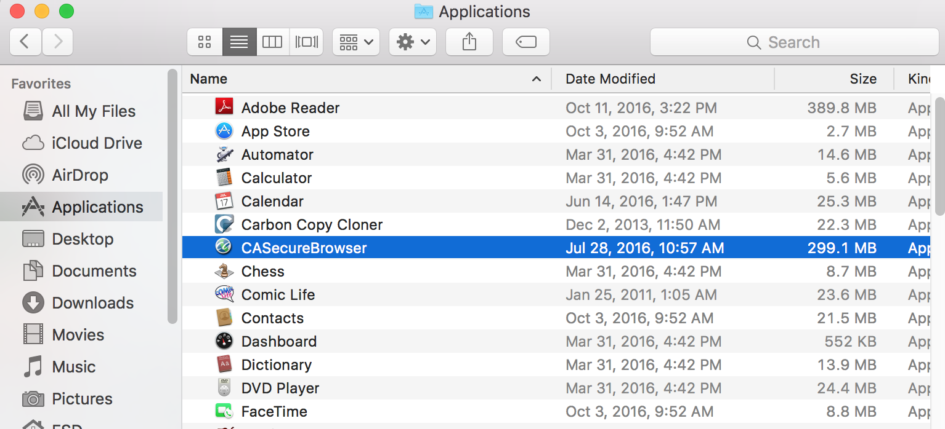

If you receive a message that the application is from an unidentified developer, open System Preferences, Security and Privacy, click on “open anyway” in the bottom section of the window.
A window may pop up asking if you are sure that you want to open it. Click on “Open”.
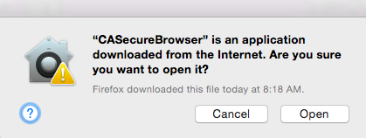
When it opens, you may receive a message saying “Access Denied” and that your computer has “Spaces” enabled (on Macs running 10.7 – 10.12)

Since you are in the TEACHER account, you do not need to change it, but when you open it in the TESTING account, you will need to disable “Spaces” if the same message pops up.

NOTE: If you used the Mac for testing last year, Spaces will already be disabled in the TESTING account.

Close the Secure Browser and RESTART.

Log in to the TESTING Account.

Click on CASecureBrowser in the dock and see if it launches version 9 of the application

If it launches without any pop-up message, then your Mission Control is already disabled, and you are READY FOR TESTING!

If not, and you need further help, please contact the IS Department.

